JCM OSCE 1/6/16

- A 6 years old boy came for ingesting a coin while playing one hour ago:

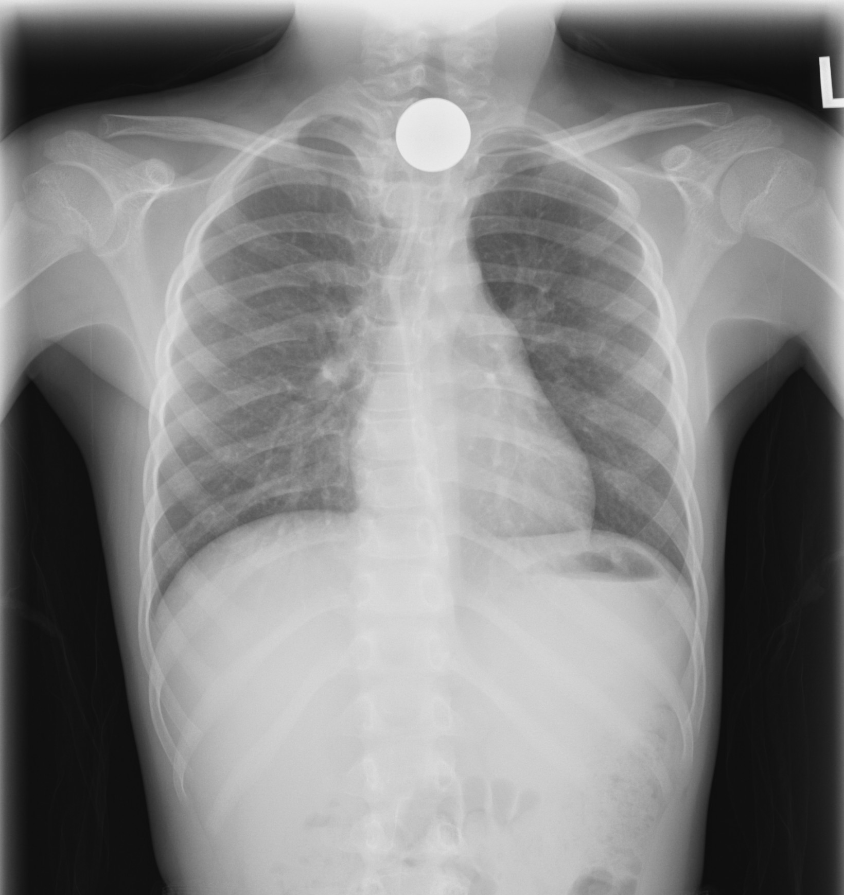

  - Where is the coin located? Trachea or esophagus?
  - What typical sign would there be if it is a button battery?
  - What are the potential complications if the coin is left for prolonged period of time?
  - What is your management for the child?

- 46 years old gentlemen came for bilateral weakness for two hours. There was no history of injury, and there was no fever, back pain or limb numbness. On physical examination, he has GCS 15/15 with stable vital signs; limb power was 1/5 over bilateral lower limbs.

  - Please state three differential diagnoses.
  - What is the POCT that can help differentiating the diagnosis?
  - Please describe the ECG:

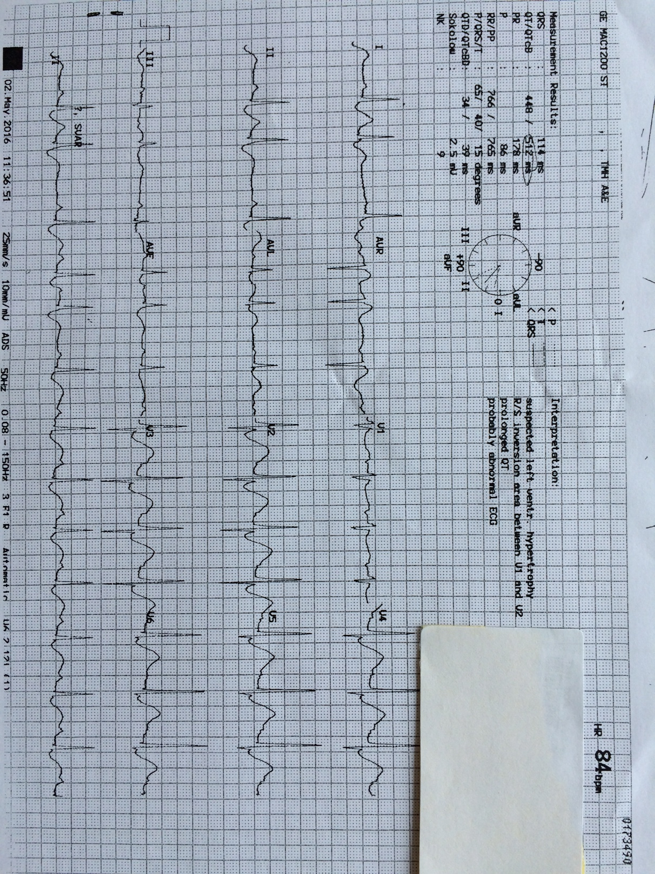

  - What is the most likely diagnosis?
  - What is the management for patient? Is there any precaution while giving the treatment?

- A 54 years old gentlemen attended AED for difficulty in breathing and sore throat for two days. On physical examination, you noted that he had fever and stridor on auscultation.

  - Please list five causes of upper airway obstruction in adult.
  - Please describe the X ray:

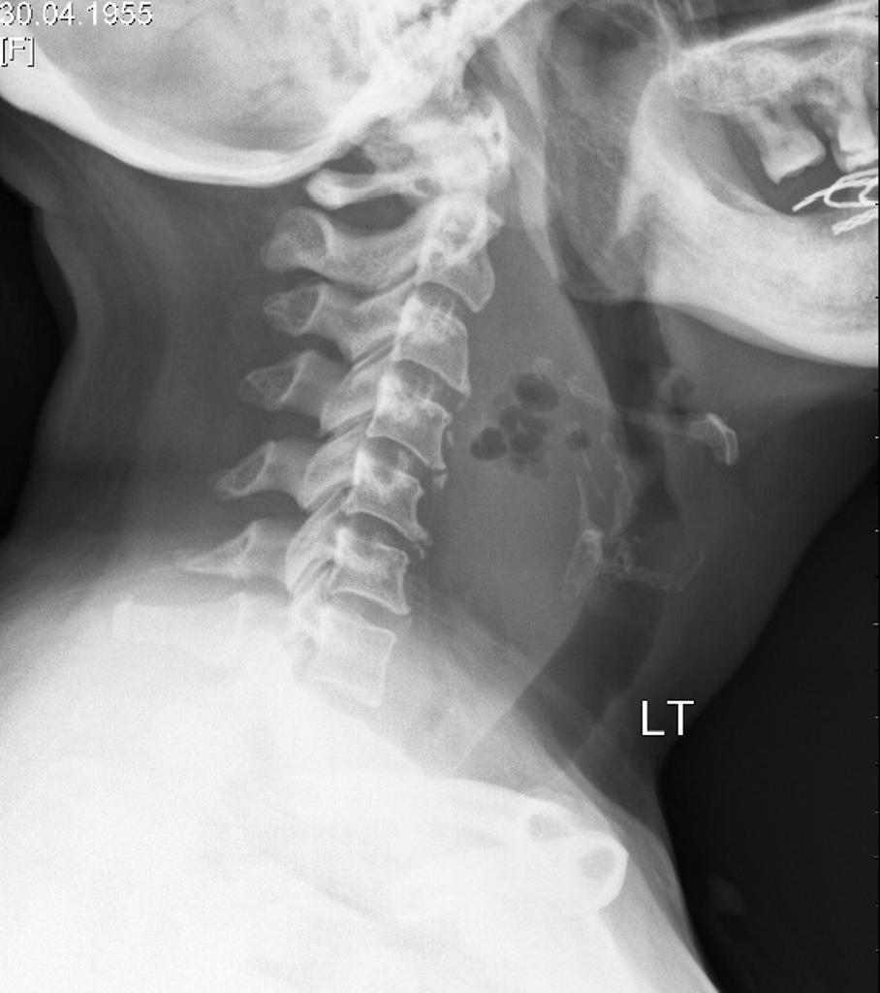

  - What is your diagnosis?
  - What is the likely cause of this condition?
  - What is your management?

- 82 years old gentlemen attended for dull chest pain for one hour. PMH: HT, DM, AF. BP 107/56mmHg, P 50/min, SpO2 97% on RA.

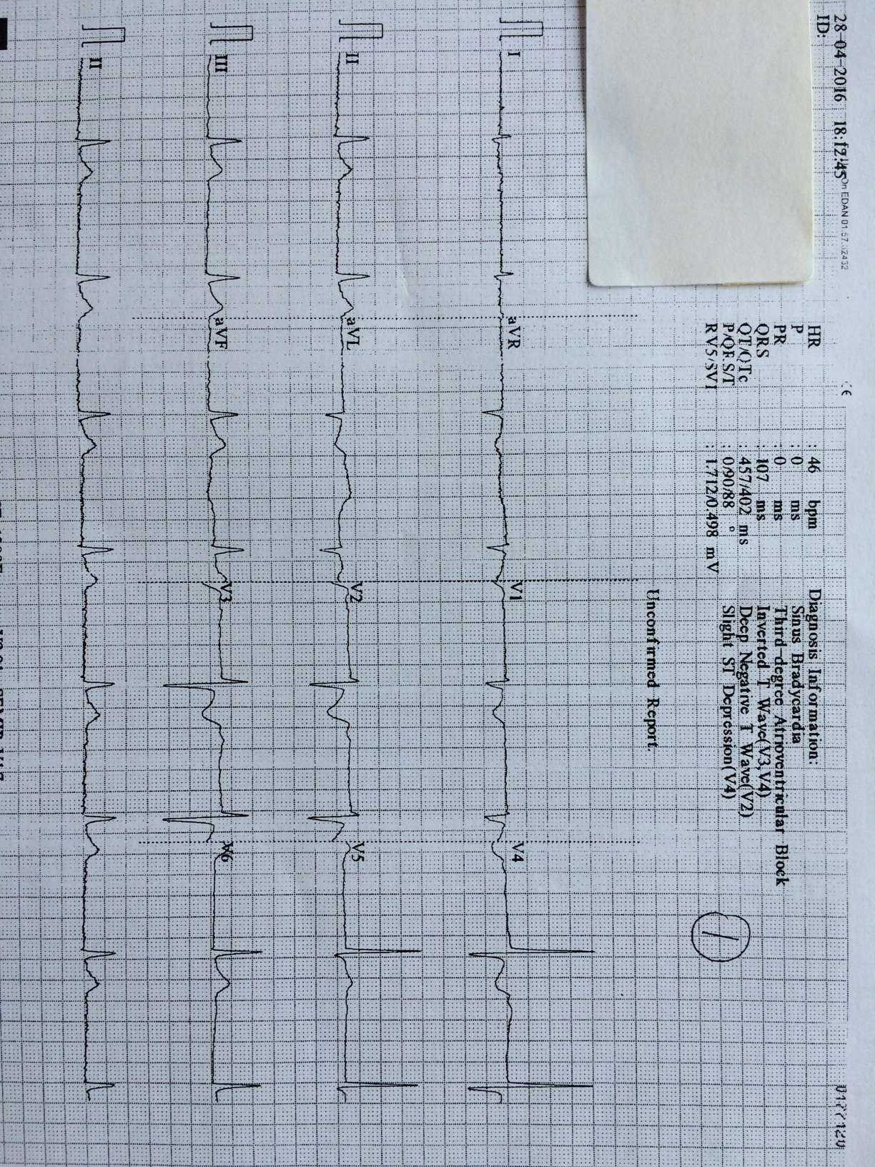

  - Please describe the ECG.
  - Two additional ECG were done:

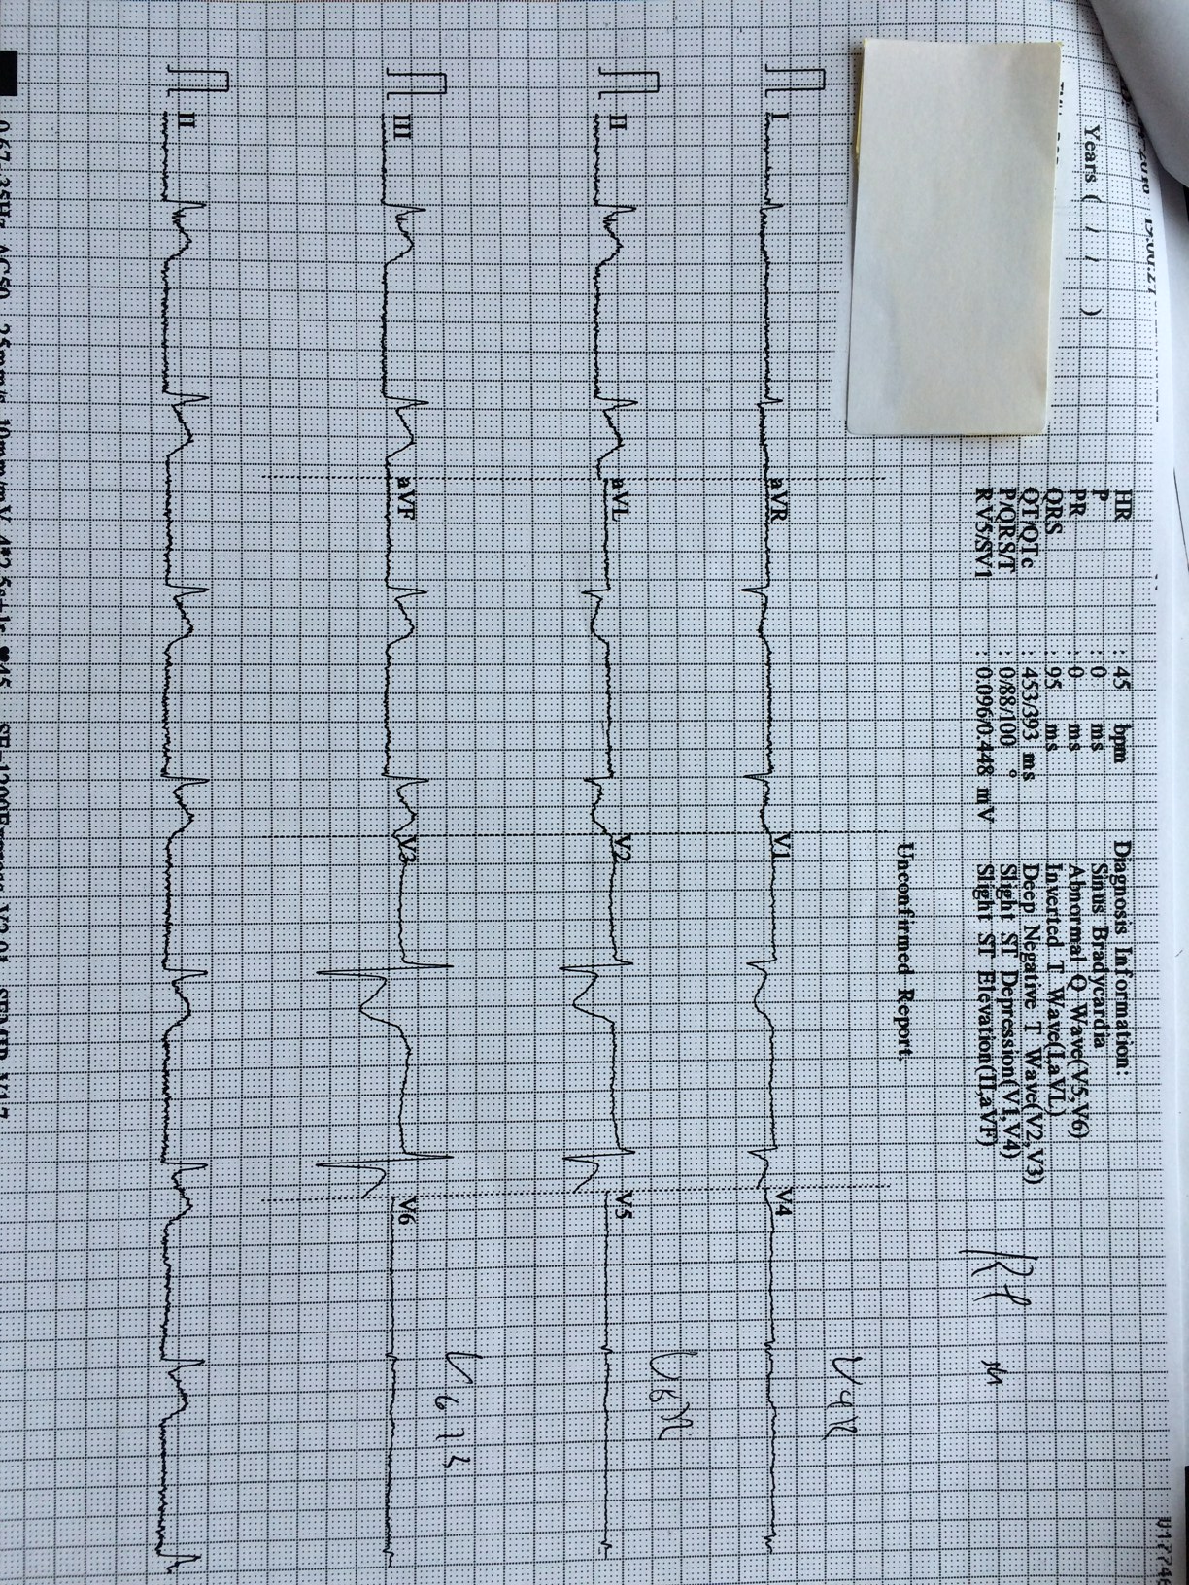

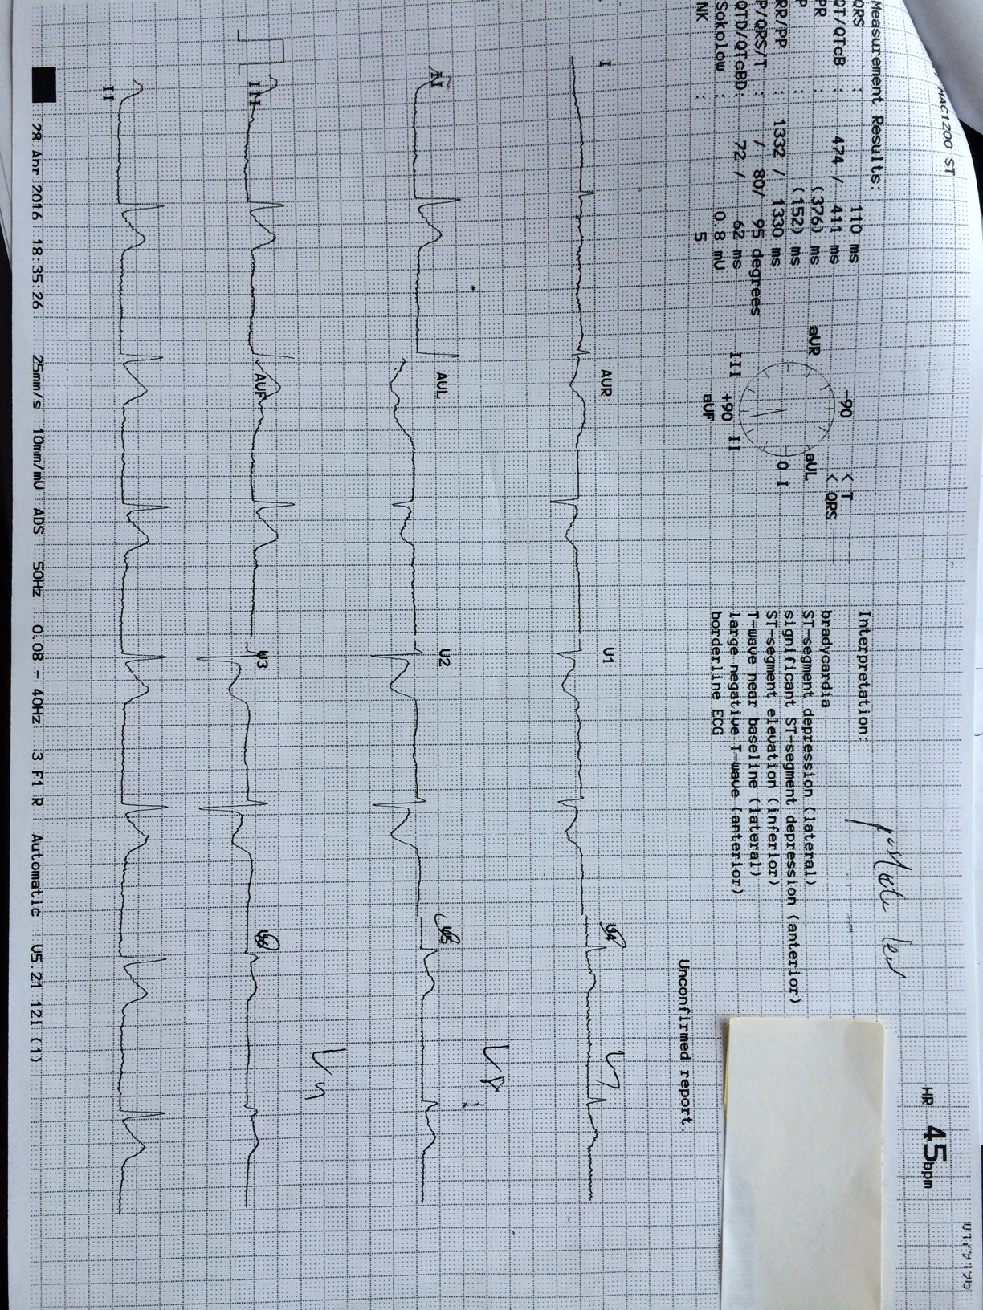

  - What is the diagnosis?
  - Please name four treatments for the patient.

- 22 years old gentlemen with history of adjustment disorder and epilepsy, attended for suicidal attempt with drug overdose with 100 tabs of 200mg sodium valproate one hour ago. At triage, GCS was E3V5M6, BP 153/77mmHg, P 125/min.

  - What GI decontamination would you consider?
  - What are the poisonings that MDAC is useful?
  - What specific blood tests can be carried out?
  - Is there antidote? When should we consider to give?
  - Suggest one way for enhanced elimination. What are the other poisonings that this method is also useful?

